Lab hw6 公衛二 梁嫚芳 b07801003

1. **Plot the Kaplan-Meier survival curves for ovarian cancer data (10 points)**

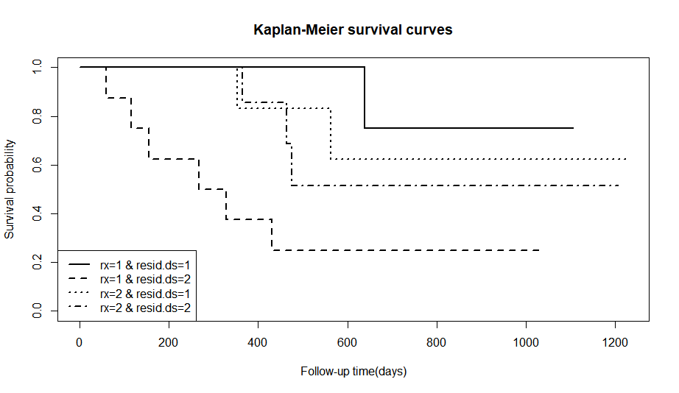

1. **Test these survival curves using log-rank test and make a conclusion**

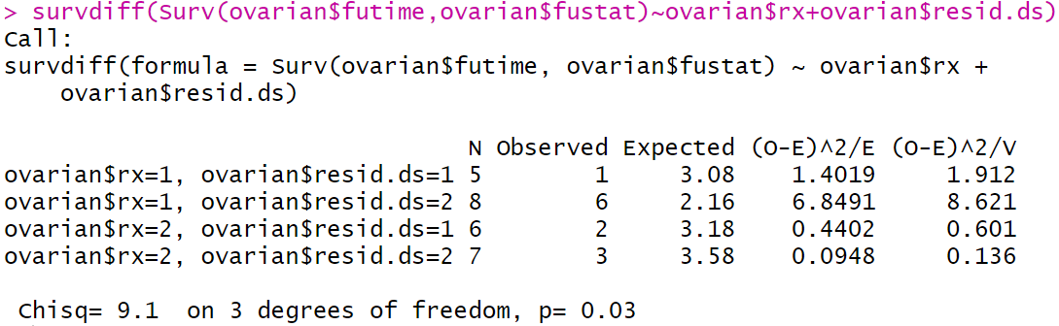rx: treatment group={1,2}

resid.ds: residual disease present={1,2}

S0(t): rx=1 & resid.ds=1

S1(t): rx=1 & resid.ds=2

S2(t): rx=2 & resid.ds=1

S3(t): rx=2 & resid.ds=1

H0: S0(t)=S1(t)=S2(t)=S3(t)

H1: S0(t), S1(t), S2(t), S3(t)不均相同

**Conclusion**: p-value=0.03<α(0.05)，Reject H0，S0(t), S1(t), S2(t), S3(t)不均相同，treatment group及residual disease present統計顯著地影響survival or censoring time(futime)。

1. **Construct a Cox proportional hazard model for estimating ovarian cancer of hazard ratio**

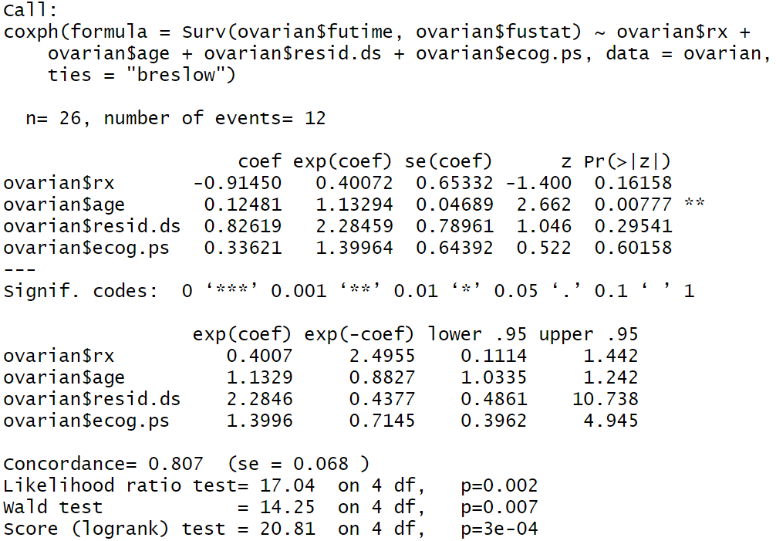

HR of treatment group=0.40072

HR of age=1.13294

HR of residual disease present=2.28459

HR of ECOG performance status=1.39964

1. **Interpret the regression coefficients with its clinical meaning in the model**

Model:

h(t |x)=h0(t)･exp(β1X1+β2X2+β3X3+β4X4)

X1: treatment group={1,2}

X2: age

X3: residual disease present={1=no,2=yes}

X4: ECOG performance status = {1 is better, see reference}

β1: 相同age, residual disease present, ECOG performance status下，treatment group為2相較1的HR增加e β1倍。

β2: 相同treatment group, residual disease present, ECOG performance status下，每增加1單位的age，對HR平均增加e β2倍。

β3: 相同treatment group, age, ECOG performance status下，residual disease present為2相較1的HR增加e β3倍。

β4: 相同treatment group, age, residual disease present，ECOG performance status為1相較reference的HR增加e β4倍。

1. **Plot the Kaplan-Meier survival curves, and compare them**

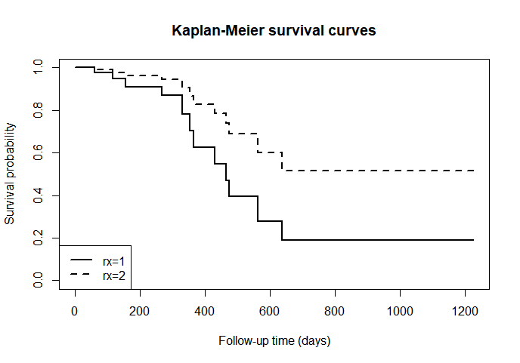

Compare:

根據左圖可知，rx=2的KM curve較rx=1的曲線下面積大，且rx=1的curve皆不高於rx=2，即treatment group(rx)有效影響survival or censoring time(futime)。

1. **Does the model hold the proportional hazards assumption? Please test it, and make a conclusion**

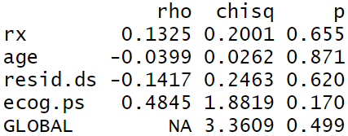After test the Proportional Hazards Assumption of a Cox Regression，從報表中可知，每個covariates的p-value皆大於α (0.05)，未達統計顯著性，global test的p-value=0.499>α(0.05)，同樣未達統計顯著性。Hence, the model holds the proportional hazards assumption.

1. **Once the model does not hold the** **proportional hazards assumption, please give a suggestion to adjust the model**

If the model doesn’t hold proportional hazards assumption, we can stratify cox proportional hazards model to regard confounding factors which breaks the proportional hazards assumption as stratified variable in order to control the confounding.

R code: Coxph(Survival Object~variable+strata(confounding variable)+…,ties=”Breslow”)